SAGARDWEEP BISWAS
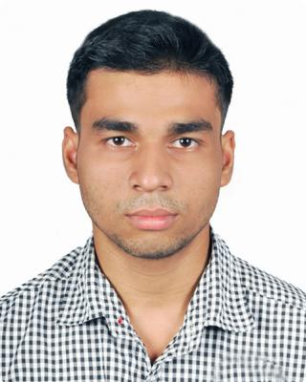

E-mail § sagar94m@gmail.com

Phone § 7908696155
WhatsApp § 8420299165

Address § TARULATA PATH, DESHBANDHU PALLY, NAIHATI,WB. PIN 743165

BIO

FATHER: LATE CHINMAY BISWAS RELIGION: HINDU SEX: MALE CATEGORY: SC

KNOWN LANGUAGE: BENGALI, ENGLISH, HINDI

EDUCATION

CLASS 10 (WBBSE) 2011
HOOGHLY BRANCH SCHOOL
PERCENTAGE 81.12%

H.S (WBCHSE) | 2011 — 2013
HOOGHLY BRANCH SCHOOL
PERCENTAGE 67.5%
B.Sc in PHYSICS(Hons) , CHEMISTRY , MATH | 2013 — 2016
HOOGHLY MOHSIN COLLEGE
PERCENTAGE 53.75%
M.Sc in PHYSICS and NUCLEAR PHYSICS | 2016 — 2018
VISVA BHARATI
PERCENTAGE 73.1%

QUALIFICATIONS

NATIONAL EXAMINATION PASSED

UGC-NET(LECTURESHIP) 2018 IN PHYSICS ,RANK 210

GATE 2019 IN PHYSICS, RANK 3123

GATE 2018

O JAM 2016

COMPUTER SKILLS:

C++ PROGRAMMING, HTML, LATEX, MS WORD ,MS POWERPOINT ,GNU ,GVIM

SUBJECTS SKILLS:

ELECTRONICS (vacuum tube, diode, bjt ,op-amp, filter ,digital electronics, microprocessor 8085, radar ,phase lock loop etc),

ELECTRODYNAMICS AND MAGNETISM,

OPTICS AND LENS (interference ,diffraction , lens combination, eye-piece ,telescopes ,aberration ,optical fiber)

LASER (theoretical)

CONDENCE MATTER,

ATOMIC AND MOLICULER PHYSICS (spectroscopy , electron spin resonance , hall effect etc)

NUCLEAR PHYSICS ( cyclotron , particle accelerator , collider ,radiation detectors)
QUANTUM PHYSICS AND MODERN QUANTUM MECHANICS

O ,CLASSICAL MECHANICS , MATH METHOD,RELATIVISTIC MECHANICS ETC

O PROJECT WORK:

NUCLEAR MAGICITY APPROCHING DRIP LINE "SUPERVISOR DR: ANAGHA CHAKRABORTY (VISVA-BHARATI)

O OTHER SKILLS:
KARATE (Shotokan, Brown belt), ASTROLOGY AND HOROSCOPE READING, YOGA EXPERT.

O CHALLENGES:
STAMMERING SPEECH DIFFICULTY, LOW VISION IN RIGHT EYE ONLY (NO FOCUS POWER)

WORKING EXPERIENCE

ADVANCED PHYSICS EXPERT AT CHEGG.COM [USA SERVER] (FEB 2019 – NOW),

TECHNICAL FACULTY AT MACHINOTHERM ENGINEERS (Kolkata) (MARCH 2019 – MAY 2019),

PhD JRF SCHOLAR AT ICSP KOLKATA (MAY 2019 – NOW).

INTERESTS

TEACHING, EDUCATION, PROJECT ADVISOR, LAB SUPERVISIOR, TECHNICAL ASSIST, SCIENTIFIC EDITOR

